JUNCTION IQ - SMART TRAFFIC MANAGEMENT SYSTEM FOR URBAN CONGESTION CONTROL
A MINI PROJECT 3 REPORT

Submitted by

Anusha Patil | (2425000174) | (B-44)
Shrutika Patil | (2425001031) | (B-50)
Adarsh Gurav | (2425000776) | (B-73)
Sanket Magdum | (2425000540) | (B-77)

in partial fulfillment for the award of the degree of

THIRD YEAR B-TECH

IN

COMPUTER SCIENCE ENGINEERING



KOLHAPUR INSTITUTE OF TECHNOLOGY’S COLLEGE OF ENGINEERING KOLHAPUR (EMPOWERED AUTONOMOUS)
OCT 2026

KOLHAPUR INSTITUTE OF TECHNOLOGY’S COLLEGE OF ENGINEERING KOLHAPUR (EMPOWERED AUTONOMOUS)

CERTIFICATE

This is to certify that the Mini Project 3 report entitled, “Junction IQ- Smart Traffic Management System for Urban Congestion Control.” submitted by “Anusha Patil (B-44), Shrutika Patil (B-50), Adarsh Gurav (B-73), Sanket Magdum (B-77)” , in partial fulfillment for the award of the degree of “ THIRD YEAR B-TECH” in “COMPUTER SCIENCE AND ENGINEERING” at
Kolhapur Institute of Technology’s College of Engineering Kolhapur (Empowered Autonomous), Kolhapur, Maharashtra, INDIA, is a record of his / her own work carried out under my / our supervision and guidance.

SIGNATURE | SIGNATURE | SIGNATURE
Dr. Lingaraj Hadimani | Mrs.Yogita Narule | Mr. Sanjay Patil
HEAD OF THE DEPARTMENT | SUPERVISOR | PBL EVALUATOR

KOLHAPUR INSTITUTE OF TECHNOLOGY’S COLLEGE OF ENGINEERING KOLHAPUR (EMPOWERED AUTONOMOUS)

DECLARATION

We hereby declare that the Mini Project III entitled, Junction IQ - Smart Traffic Management System for Urban Congestion Control. submitted to Kolhapur Institute of Technology’s College of Engineering Kolhapur (Empowered Autonomous), Kolhapur, Maharashtra, INDIA in the partial fulfillment of the award of the Degree of “THIRD YEAR B-TECH” in “COMPUTER SCIENCE AND ENGINEERING” is a bonafide work carried out by us. The material contained in this Project has not been submitted to any University or Institution for the award of any degree.

NAME OF THE STUDENT(S)
Anusha Patil (2425000174) (B-44) Shrutika Patil (2425001031) (B-50) Adarsh Gurav (2425000776) (B-73) Sanket Magdum (2425000540) (B-77)

Place: Kolhapur
Date:

KOLHAPUR INSTITUTE OF TECHNOLOGY’S COLLEGE OF ENGINEERING KOLHAPUR (EMPOWERED AUTONOMOUS)

ACKNOWLEDGEMENT

We take this opportunity to express our sincere gratitude to all those who supported and guided us in the successful completion of our project titled “Junction IQ-Smart Traffic Management System for Urban Congestion Control.” We are deeply thankful to our respected guide Mrs. Yogita Narule and PBL Evaluator Mr. Sanjay Patil for valuable guidance, suggestions, and constant encouragement throughout the development of this project. We also express our heartfelt thanks to our Head of Department, Dr. Lingaraj Hadimani, for providing the required facilities and a motivating environment for our work. Our sincere appreciation extends to all the faculty members of the Department of Computer Science And Engineering for their helpful feedback and assistance. Finally, we thank our friends and family for their continuous support and motivation, which greatly contributed to the successful completion of this project.

NAME OF THE STUDENT(S)

Anusha Patil (2425000174) (B-44) Shrutika Patil (2425001031) (B-50) Adarsh Gurav (2425000776) (B-73) Sanket Magdum (2425000540) (B-77)

Place: Kolhapur
Date:

KOLHAPUR INSTITUTE OF TECHNOLOGY’S COLLEGE OF ENGINEERING KOLHAPUR (EMPOWERED AUTONOMOUS)

ABSTRACT

Junction IQ - Smart Traffic Management System for Urban Congestion Control
Junction IQ - The Smart Traffic Management System for Urban Congestion Control aims to reduce traffic congestion, minimize vehicle waiting time, and improve traffic flow at intersections. Traditional traffic signals use fixed timings that may not match actual traffic conditions, resulting in unnecessary delays and uneven congestion.
The proposed system uses SUMO, NetEdit, Python, and TraCI API to simulate traffic and dynamically adjust signal timings based on vehicle count, lane density, vehicle speed, and waiting time. A rule-based decision-making mechanism determines green-light durations and provides priority to ambulances according to predefined rules.
The system's performance is evaluated by comparing dynamic signal control with conventional fixed-time control under simulated traffic conditions. The recorded results show a reduction in average vehicle waiting time from 118 seconds under fixed-time control to 70.48 seconds under dynamic-time control, representing an improvement of approximately 40.27%. These results demonstrate the potential of traffic-responsive signal control to reduce unnecessary waiting and improve emergency vehicle movement within a simulated road network. The proposed system can be further extended to support complex road networks, coordinated traffic signals at multiple intersections, and potential real-world deployment.

TABLE OF CONTENTS

CHAPTER NO. NO. | TITLE | PAGE
 | DECLARATION |  | i
 | ACKNOWLEDGEMENT | ii
 | ABSTRACT  TABLE OF CONTENT | iii iv
1. | INTRODUCTION | 1-5
 | 1.1. Project Category | 1
 | 1.2. Problem Formulation | 1
 | 1.3. Identification/Reorganization of Need | 2
 | 1.4. Existing System | 2
 | 1.5. Proposed System | 5
 | 1.6. Objectives | 5
 | 1.7. Unique Features | 5
2. | Requirement Analysis & System Specification | 6-7
 | 2.1. Feasibility Study | 6
 | 2.2. Software Requirement Specification | 6
 | 2.3. Validation | 7
 | 2.4. Expected Hurdles | 7
 | 2.5. SDLC Model | 7
3. | System Design | 8-12
 | 3.1. Design Approach | 8

  - Detailed Design 8
  - Structured Design Tools 9
10
  - User Interface Design
  - Methodology 11
  - System Design Flowchart 12
- Implementation, Testing & Maintenance 13-16
4 1. Implementation Tools 13
4 2. Coding Standards 13
4 3. Project Scheduling 13
- 4. Testing 14
- Results and Discussion 17-24
- 1. User Interface Representation 17
5 2. Module Description 17
- 3. Snapshots of System 18
  - Back-End Representation 24
- Conclusion And Future Scope 25
- 1. Conclusion 25
6 2. Future Scope 25

REFERENCES AND BIBLIOGRAPHY 26-28

5

Chapter 1

INTRODUCTION

Project Category

Our project, Junction IQ - Smart Traffic Management System for Urban Congestion Control, belongs to the domain of Intelligent Transportation Systems (ITS) and Smart City Solutions. It focuses on dynamically controlling traffic signals based on vehicle count and traffic conditions while providing priority to emergency vehicles such as ambulances. The system uses SUMO for traffic simulation, NetEdit for designing road networks and intersections, Python for implementing traffic control logic, and the TraCI API to establish communication between Python and SUMO. These technologies enable the system to simulate different traffic scenarios, adjust signal timings, and evaluate its effectiveness in reducing congestion and vehicle waiting time.

Problem Formulation

Traditional traffic signals generally operate with fixed timings that do not adapt to changing traffic conditions, resulting in long queues, uneven traffic distribution across lanes, and unnecessary vehicle waiting time. During peak hours, some lanes experience heavy congestion while others remain relatively less occupied, leading to inefficient use of green-light time. Additionally, emergency vehicles such as ambulances may face delays at intersections because conventional traffic signals do not always provide priority during emergencies. The absence of automatic, traffic-responsive signal control further contributes to congestion and increased travel time. The objective of this project is to develop a Smart Traffic Management System that dynamically adjusts signal timings based on vehicle count and lane density while providing priority to emergency vehicles through predefined rules. The proposed system aims to reduce vehicle waiting time, improve traffic flow, minimize congestion, and evaluate the effectiveness of dynamic signal control through SUMO simulation.

Identification / Reorganization of Need

The need for this project arises from the limitations of fixed-time traffic signals in managing changing traffic conditions. During peak hours, some lanes experience heavy congestion, while others have fewer vehicles, resulting in inefficient signal timing and increased waiting time. Therefore, an intelligent system is required to analyze traffic conditions and allocate green-light duration according to actual traffic demand. The major requirements include dynamic control to adjust signal timings based on congestion, traffic data collection to analyze vehicle count, lane density, speed, and waiting time, and rule-based decision-making to determine suitable green-light durations within predefined limits. The system also requires an emergency vehicle prioritization mechanism to provide ambulances with priority under specified conditions. Finally, performance evaluation is carried out using SUMO simulation by comparing dynamic-time and fixed-time signal control to assess improvements in traffic flow and vehicle waiting time.

Existing System

The existing traffic management systems discussed in the literature review primarily use fixed-time signals, adaptive traffic control algorithms, and simulation-based approaches to manage traffic congestion. Several studies have explored fuzzy logic, rule-based decision-making, and artificial intelligence techniques to adjust signal timings according to traffic conditions. SUMO has been widely used to simulate traffic scenarios and evaluate improvements in vehicle waiting time, traffic flow, and congestion. Some research studies also focus on emergency vehicle prioritization using GPS, RFID, IoT sensors, and dynamic signal control. However, these approaches have certain limitations, including dependence on costly infrastructure, limited real-world implementation, and difficulties in handling complex traffic conditions. Some studies focus on individual intersections or road network optimization rather than integrating dynamic signal timing and emergency vehicle priority into a single system. The existing research provides a foundation for developing intelligent traffic management solutions, but there is still scope for a simulation-based system that combines vehicle count analysis, rule-based dynamic signal timing, and ambulance prioritization. Our proposed project addresses this need by using SUMO, Python, and the TraCI API to adjust traffic signal timings according to simulated traffic conditions and evaluate system performance by comparing fixed-time and dynamic-time signal control.

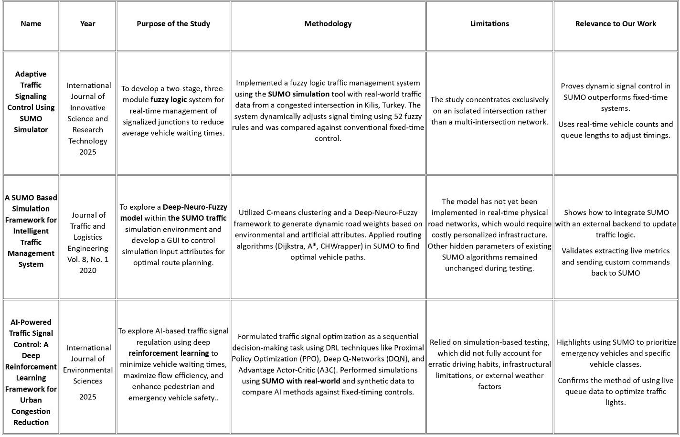
Table 1 . Literature Review
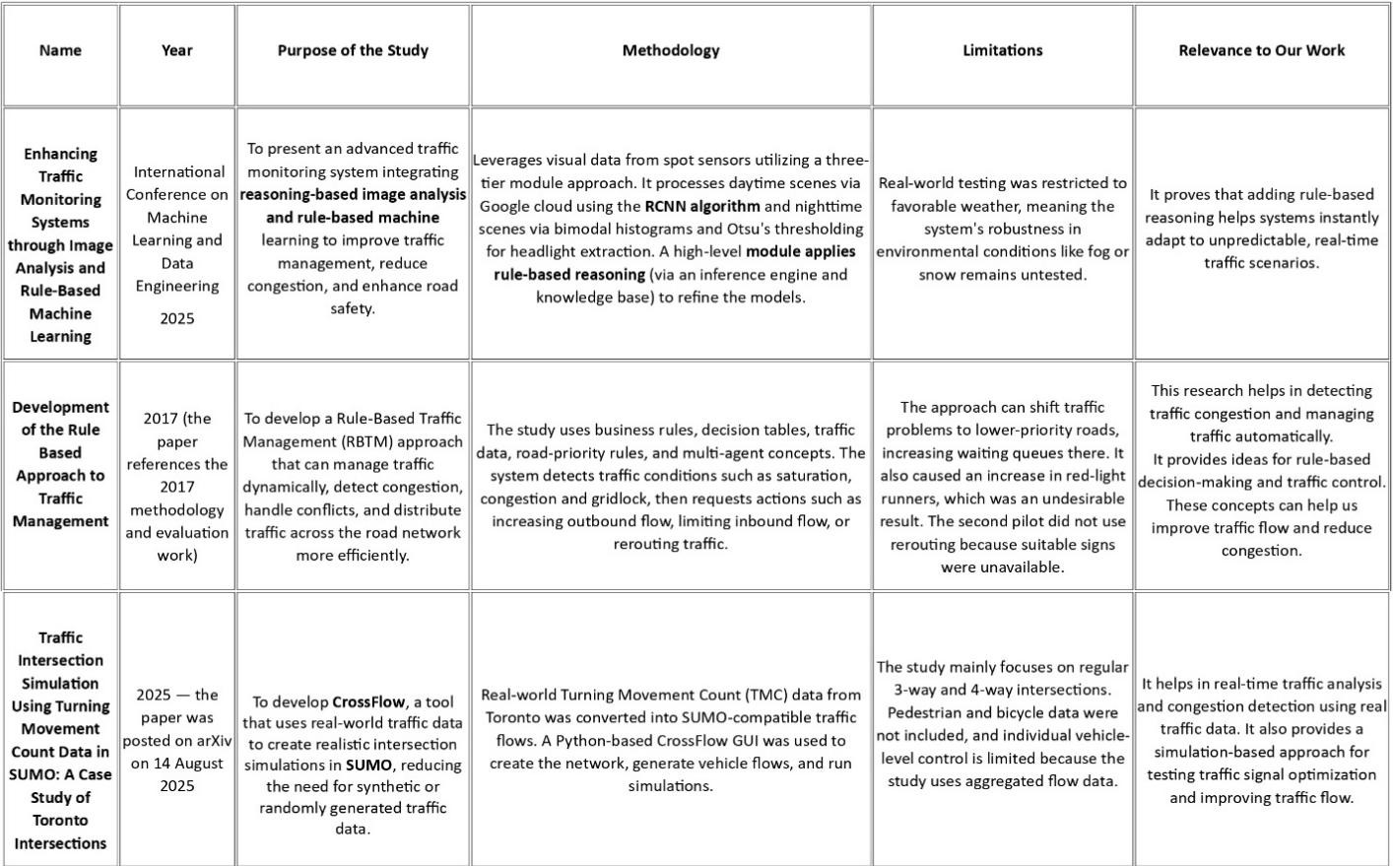
Table 2. Literature Review

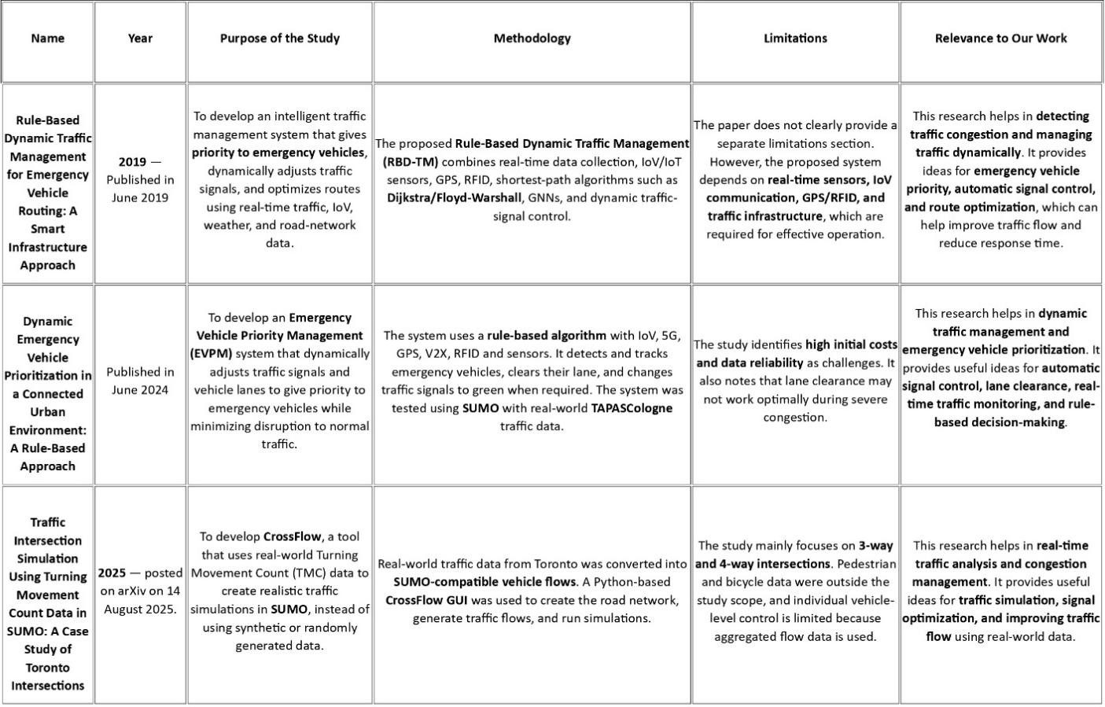
Table 3. Literature Review
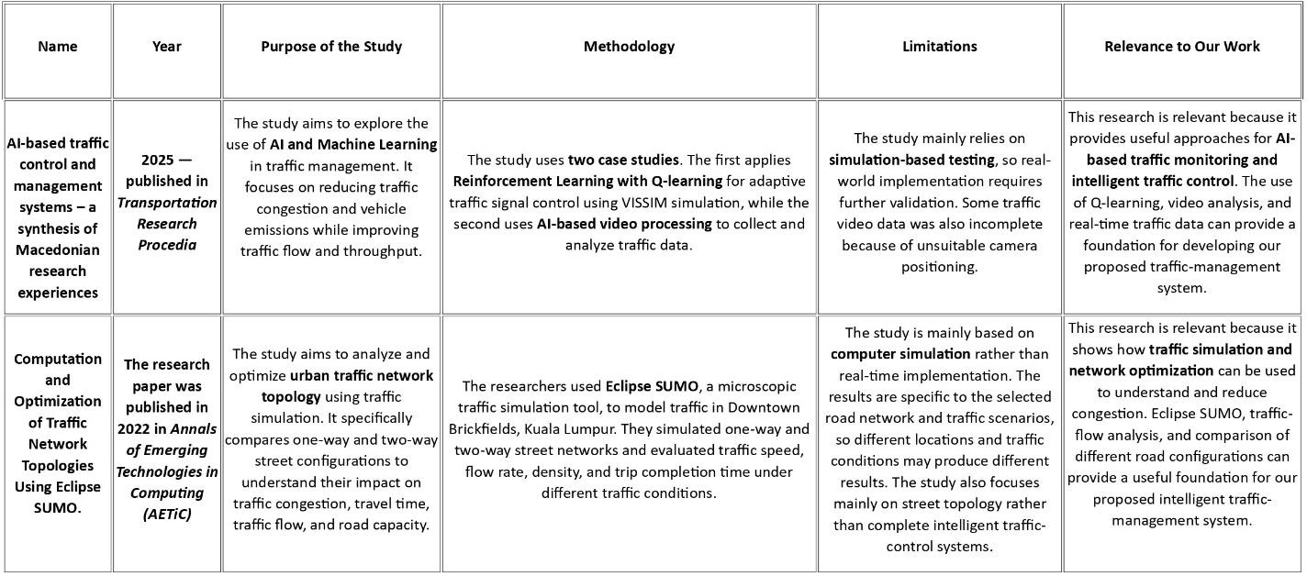
Table 4. Literature Review

Proposed System

The proposed Junction IQ - Smart Traffic Management System for Urban Congestion Control uses SUMO, Python, and the TraCI API to manage traffic signals dynamically. The system analyzes vehicle count, lane density, vehicle speed, and waiting time to determine suitable green-light durations based on traffic demand. A rule-based mechanism adjusts signal timings within predefined limits and prioritizes ambulances under specific conditions. The system is tested in SUMO under different traffic scenarios, including varying congestion levels and emergency situations. Its performance is evaluated by comparing fixed-time and dynamic-time signal control using parameters such as vehicle waiting time, queue length, and traffic flow. The main aim is to reduce traffic congestion, minimize delays, and improve emergency vehicle movement.

Objectives

The main objective of the Junction IQ - Smart Traffic Management System for Urban Congestion Control are :

    - To Build Traffic Simulation
    - To Develop a rule based logic model to manage congestion
    - To Develop Smart Traffic Signals by dynamic timer
    - To Give Priority to Ambulances
    - To Evaluate System Performance

1. 7 Unique Features

The system incorporates a rule-based decision engine that analyzes traffic conditions and applies predefined rules to determine suitable green-light durations while maintaining signal timing limits. SUMO and TraCI are used for simulation-based testing under different traffic scenarios, including varying vehicle types, congestion levels, and emergency vehicle situations. The system's performance is evaluated by comparing fixed-time and dynamic-time traffic signal control. The recorded results show a reduction in average waiting time from 118 seconds to 70.48 seconds, representing a 40.27 % reduction under the tested simulation conditions.

Chapter 2

REQUIREMENT ANALYSIS & SYSTEM SPECIFICATION

Feasibility Study

The Smart Traffic Management System for Urban Congestion Control is evaluated based on technical, economic, and operational feasibility to ensure its practicality and effectiveness. Technical Feasibility: The project uses SUMO, NetEdit, Python, and the TraCI API for road network design, traffic simulation, and dynamic traffic signal control. The system adjusts signal timings based on vehicle counts and traffic congestion while providing priority to emergency vehicles such as ambulances and fire brigades. Economic Feasibility: The project is cost-effective because all the required software tools are open-source and freely available, reducing development and licensing expenses. It can be developed and tested on an existing computer without requiring expensive hardware or physical traffic infrastructure. Operational Feasibility: The system can be tested in a simulated environment under different traffic conditions, including normal traffic, heavy congestion, and emergency situations. Its performance can be evaluated using vehicle waiting time, queue length, traffic flow, and emergency vehicle waiting time.

Software Requirement Specification (SRS)

The Software Requirement Specification defines the hardware and software required to develop and execute the project. Software Requirements: SUMO is used for traffic simulation, NetEdit for road and intersection design, Python for implementing the rule-based decision engine, and the TraCI API for communication between Python and SUMO. Hardware Requirements: A computer or laptop capable of running SUMO simulations and Python programs is required. Sufficient RAM and processing power help execute simulations smoothly. Functional Requirements: The system must collect vehicle count, lane density, speed, and waiting time, dynamically determine green-light durations, and provide ambulance priority according to predefined rules.

Validation
Validation ensures that the proposed system works according to its objectives and produces the expected results.The system is tested using different traffic scenarios in SUMO to verify vehicle data collection, dynamic signal timing, and emergency vehicle prioritization. The results of dynamic-time control are compared with fixed-time control using average waiting time as a key performance parameter. In the recorded simulation results, average waiting time decreased from
118 seconds to 70.48 seconds, representing a 40.27% reduction. This indicates improved performance under the tested simulation conditions. Additional testing is required to evaluate the system under different traffic densities and emergency situations.

Expected Hurdles

During development, the project may face challenges in connecting Python with SUMO through the TraCI API and ensuring accurate collection of vehicle information. Incorrect vehicle counts or traffic data may lead to unsuitable signal timing decisions.Another challenge is implementing emergency vehicle prioritization without creating unnecessary delays for other lanes. Designing appropriate green-light durations and handling changing traffic conditions may also require repeated testing.These hurdles can be addressed through systematic debugging, testing individual modules, verifying vehicle information, and evaluating the system under different traffic scenarios.

SDLC Model

The Iterative SDLC Model is suitable for this project because the traffic management system can be developed, tested, and improved through repeated cycles. Initially, project requirements are identified and the road network is designed using NetEdit. Next, traffic simulation is configured in SUMO, and Python is connected through TraCI to implement the rule-based signal control mechanism. The system is then tested for vehicle count-based signal timing, traffic congestion, and emergency vehicle prioritization. The results are analyzed, and necessary modifications are made to improve system performance. This process continues until the system achieves its intended objectives.The iterative approach allows errors to be identified early and enables the traffic control logic to be improved gradually.

Chapter 3

SYSTEM DESIGN

Design Approach

The Junction IQ - Smart Traffic Management System for Urban Congestion Control follows a modular design approach in which the complete system is divided into smaller modules, each performing a specific task. The main modules include road network design, traffic simulation, vehicle data collection, traffic condition analysis, dynamic signal timing, and emergency vehicle prioritization. NetEdit is used to design roads, lanes, and intersections, while SUMO simulates vehicle movement under different traffic conditions. Python processes the traffic information and applies predefined rules to determine suitable signal timings. The TraCI API establishes communication between Python and SUMO, allowing the system to collect traffic data and update signal states during simulation. This approach makes the system easier to develop, test, debug, and improve.

Detailed Design
The detailed design describes the internal working of each module and how the modules interact with one another. First, a road network with multiple incoming lanes and traffic signals is created using NetEdit. SUMO is then configured to simulate different types of vehicles, such as cars, bikes, trucks, and ambulances. During simulation, Python uses the TraCI API to collect vehicle count, lane density, vehicle speed, and waiting time. These parameters are analyzed by a rule-based decision engine to determine the green-light duration for each lane. Lanes with greater traffic demand can receive higher green-time priority, while predefined limits prevent signal durations from becoming unsuitable. The system also checks for emergency vehicles and applies the configured priority rules when an ambulance is detected. Finally, Python sends the signal control commands to SUMO, and the updated traffic conditions are observed through the simulation.

Structured Design Tools

The project uses SUMO, NetEdit, Python, and the TraCI API as its main design and development tools. SUMO provides a microscopic traffic simulation environment in which individual vehicles and their movements can be observed. NetEdit is used to create and modify road networks, lanes, junctions, and traffic signal configurations. Python is responsible for implementing the traffic analysis and rule-based decision-making logic.The TraCI API acts as a communication interface between Python and SUMO, enabling the collection of vehicle information and the control of traffic signals while the simulation is running. These tools work together to develop and evaluate the proposed dynamic traffic management system. Their modular integration also makes it easier to modify traffic rules and test different scenarios.

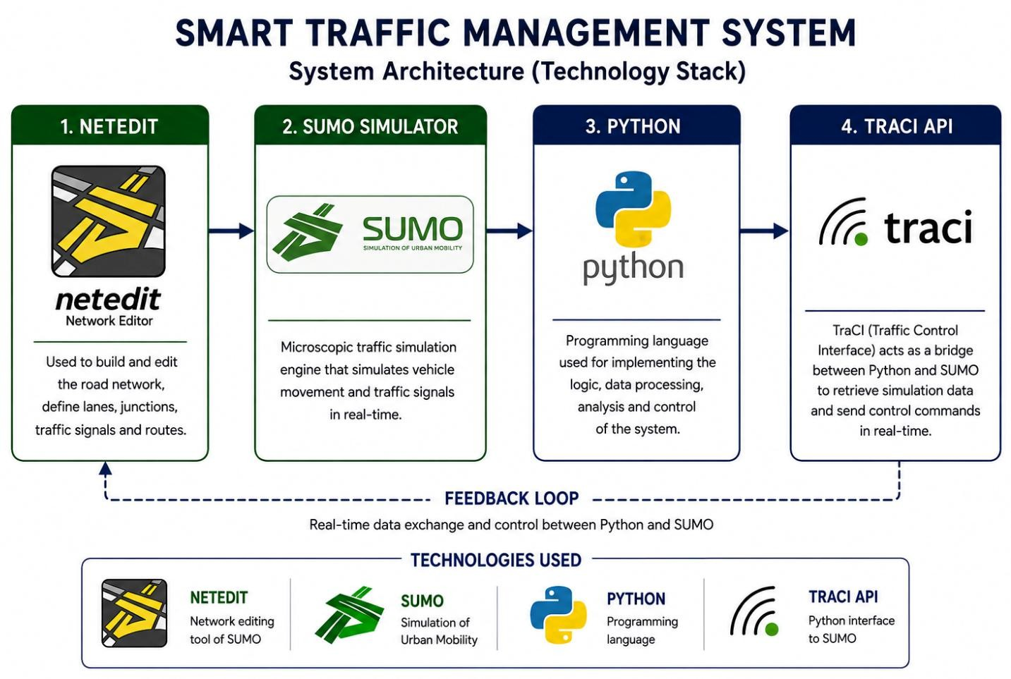

Diagram 1. System Architecture

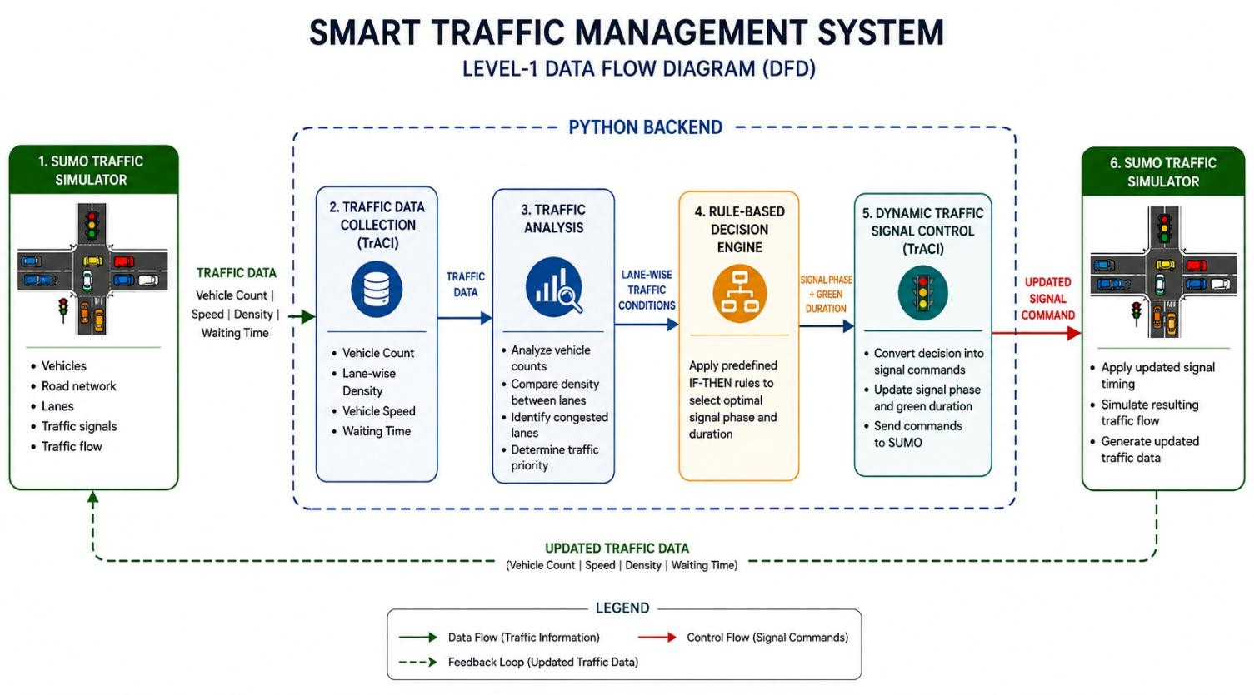

Diagram 2. Data Flow Diagram

User Interface Design

The user interface of the project is primarily based on the SUMO graphical user interface (GUI), which provides a visual representation of the simulated road network and traffic conditions. It displays roads, lanes, vehicles, and traffic signals, allowing users to observe the movement of vehicles through intersections.During simulation, users can monitor how traffic signals change according to the implemented control logic and how vehicles respond to different green-light durations. Different vehicle types, including emergency vehicles, can be observed to evaluate their movement through the road network. The interface also helps identify congestion, long vehicle queues, and delays under different traffic conditions.This visual representation makes it easier to understand system behaviour, test signal control decisions, and compare fixed-time and dynamic-time traffic management.

Methodology

The project methodology consists of road network creation, traffic simulation, data collection, traffic analysis, signal control, and performance evaluation. Initially, the road network and intersections are designed using NetEdit. The network is then configured in SUMO with appropriate vehicle routes, vehicle types, and traffic signals. Next, Python is connected to SUMO through the TraCI API to collect traffic information during simulation.The collected parameters, including vehicle count, lane density, speed, and waiting time, are analyzed by a rule-based decision engine. Based on the traffic conditions, the system determines suitable green-light durations and updates the traffic signals. If an ambulance is detected, the predefined emergency-priority mechanism is applied.The simulation continues to collect updated traffic information and adjust signal timings accordingly. Finally, the performance of dynamic-time control is compared with fixed-time control using average waiting time and other relevant traffic observations.

System Design Flowchart
Below is the logical flow of the system:

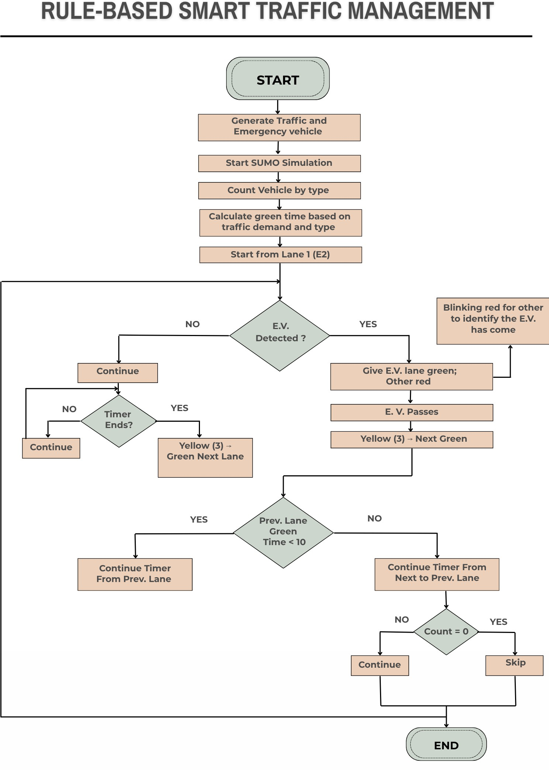
Diagram 3. All Rule Flow chart

Chapter 4

IMPLEMENTATION, TESTING & MAINTENANCE

Implementation Tools

The Junction IQ - Smart Traffic Management System for Urban Congestion Control is implemented using SUMO, NetEdit, Python, and the TraCI API.SUMO (Simulation of Urban Mobility): SUMO is an open-source traffic simulator used to simulate individual vehicles, their movements, and traffic flow at intersections. It allows the system to test different traffic conditions, vehicle types, and signal control strategies in a virtual environment. NetEdit: NetEdit is used to design and modify the road network. It helps create roads, lanes, junctions, and traffic signal configurations required for the simulation. Python: Python is used to develop the rule-based decision engine. It processes traffic information, including vehicle count, vehicle speed, to determine suitable green-light durations. It also implements the rules for emergency vehicle prioritization.TraCI API: The Traffic Control Interface (TraCI) connects Python with SUMO. It allows Python to retrieve vehicle information and send traffic commands while the simulation.

Coding Standards

The project follows basic coding standards to maintain code readability and reliability. Meaningful variable names, proper indentation, comments, and modular programming are used. The Python code is divided into functions for vehicle data collection, signal timing calculation, and emergency vehicle prioritization. Error handling helps manage connection and simulation issues.

Project Scheduling
Project scheduling involves dividing the development process into phases and allocating sufficient time to complete each activity. The project follows a systematic approach, beginning with requirement analysis and ending with testing, performance evaluation, and documentation. Initially, the problem statement is finalized, existing traffic management approaches are studied, and the system architecture is prepared. Next, SUMO is installed and the road network is created using NetEdit. After configuring the simulation environment, Python is connected to SUMO through the TraCI API.The next phase involves implementing the rule-based traffic control mechanism. Vehicle

count, lane density, speed, and waiting time are analyzed to determine suitable signal timings. Emergency vehicle prioritization is then implemented and integrated into the decision-making process.Finally, the complete system is tested under different simulated traffic conditions. The results of fixed-time and dynamic-time signal control are compared to evaluate the reduction in average waiting time. Necessary corrections are made, and the final report, diagrams, results, and presentation are prepared.

Testing

Testing verifies that the system works correctly under different simulated traffic conditions. Individual modules are checked for accurate vehicle data collection and signal timing decisions. Integration testing verifies communication between Python and SUMO, while functional testing checks dynamic signal control and ambulance prioritization.Performance testing compares fixed-time and dynamic-time signal control. The recorded results show that average waiting time decreased from 118 seconds to 70.48 seconds, representing a 40.27% reduction under the tested simulation conditions.

Observation Table :
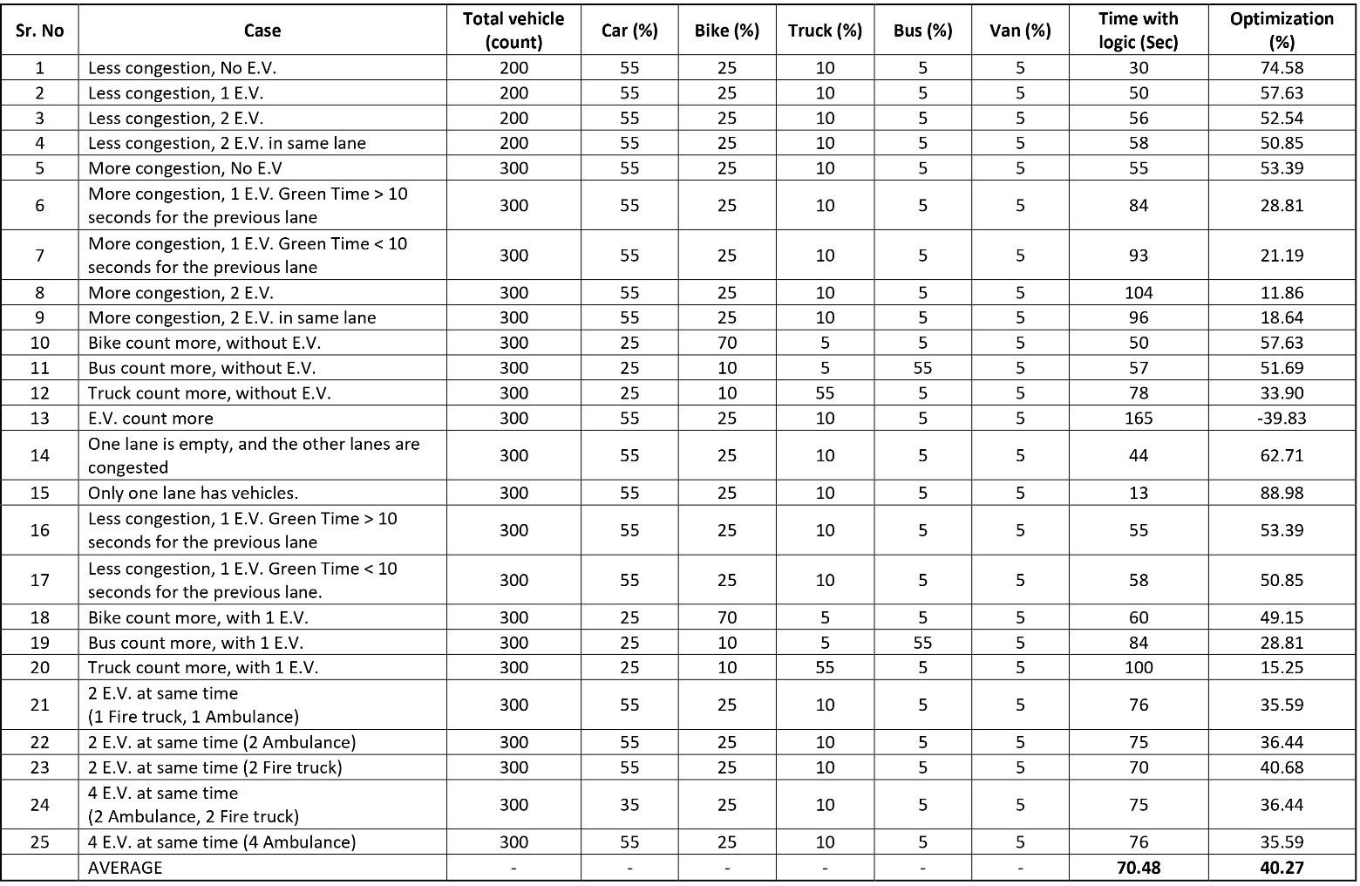

Table 5. Observation table with case and count of vehicles

Fixed Signal Timer : 118

Result | Time with logic | optimization (%)
Case - 1 | 30 | 74.57
Case - 2 | 50 | 57.62
Case - 3 | 56 | 52.54
Case - 4 | 58 | 50.84
Case - 5 | 55 | 53.38
Case - 6 | 84 | 28.81
Case - 7 | 93 | 21.18
Case - 8 | 104 | 11.86
Case - 9 | 96 | 18.64
Case - 10 | 50 | 57.62
Case - 11 | 57 | 51.69
Case - 12 | 78 | 33.89
Case - 13 | 165 | -39.83
Case - 14 | 44 | 62.71
Case - 15 | 13 | 89.98
Case - 16 | 55 | 53.38
Case - 17 | 58 | 50.84
Case - 18 | 60 | 49.15
Case - 19 | 84 | 28.81
Case - 20 | 100 | 15.25
Case - 21 | 76 | 35.59
Case – 22 | 75 | 36.44
Case – 23 | 70 | 40.67
Case – 24 | 75 | 36.44
Case – 25 | 76 | 35.59
 | Avg = 71.48 | Avg = 40.27

Table 6. Observation table with case and respective times

Optimization (%) =
Time without logic − Time with logic
Time without logic × 𝟏𝟎𝟎

Chapter 5

RESULTS & DISCUSSIONS

User Interface Representation

The user interface of the Smart Traffic Management System is represented through the SUMO graphical user interface (GUI). It displays the road network, lanes, vehicles, and traffic signals during simulation. Users can observe vehicle movement, traffic congestion, and signal changes under different traffic conditions.The interface also helps visualize the behaviour of the dynamic signal control mechanism and ambulance prioritization. This visual representation makes it easier to understand and evaluate the system's performance.

Module Description

The project consists of several modules that work together to manage traffic signals dynamically. The Road Network Design Module uses NetEdit to create roads, lanes, and intersections.The Traffic Simulation Module uses SUMO to simulate vehicle movement and traffic flow. The Data Collection Module collects vehicle count, lane density, speed, and waiting time through TraCI. The Decision-Making Module, implemented in Python, analyzes traffic conditions and determines suitable green-light durations using predefined rules.The Emergency Vehicle Prioritization Module detects ambulances in the simulation and applies the configured priority rules. Finally, the Signal Control Module sends commands through TraCI to update traffic signals according to the calculated timings

Snapshots of System

System snapshots provide visual evidence of the working of the Smart Traffic Management System. Screenshots of the SUMO simulation can show the designed road network, vehicle movement, traffic signals, and congestion under different traffic conditions.Additional snapshots can demonstrate dynamic signal timing and ambulance prioritization. Screenshots of different test scenarios can also illustrate how the system responds to varying vehicle counts, heavy traffic, and emergency situations.These snapshots help demonstrate the implementation and functioning of the proposed system.

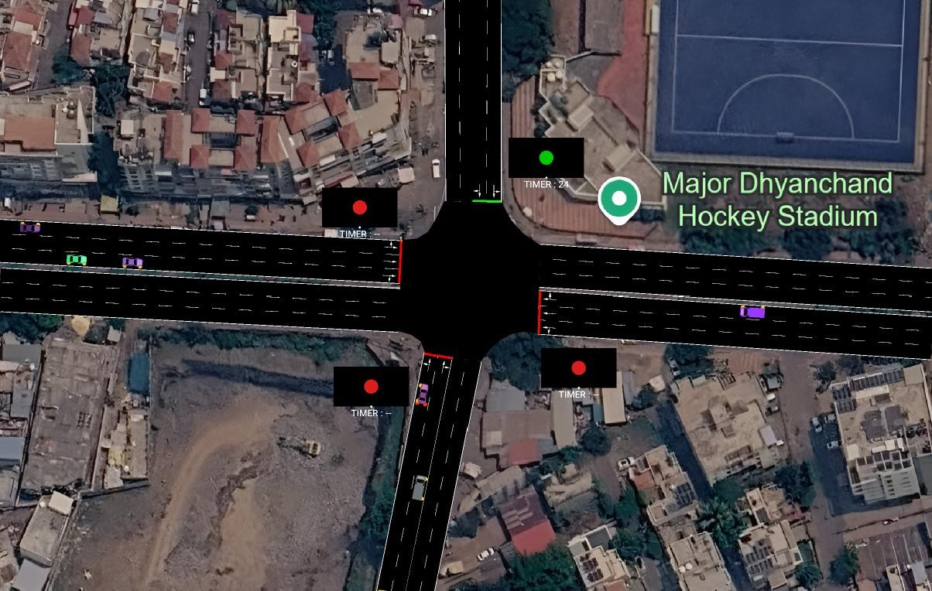
Diagram 4. Simulation without logic

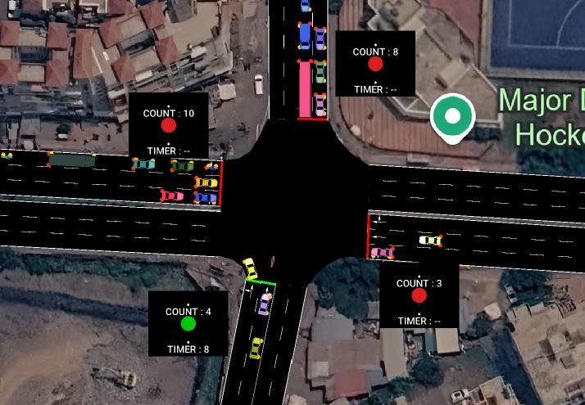
Diagram 5. Simulation with logic

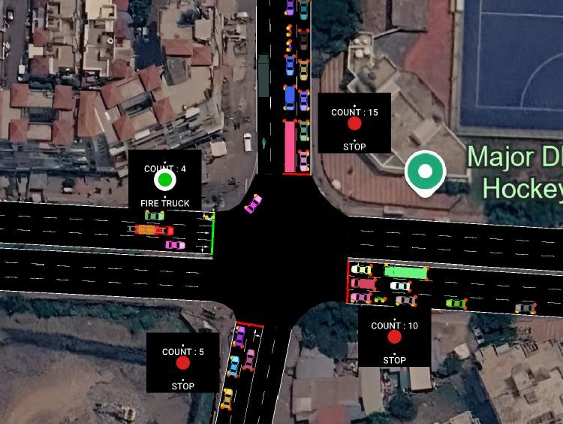

Diagram 6. E. V. Fire Truck

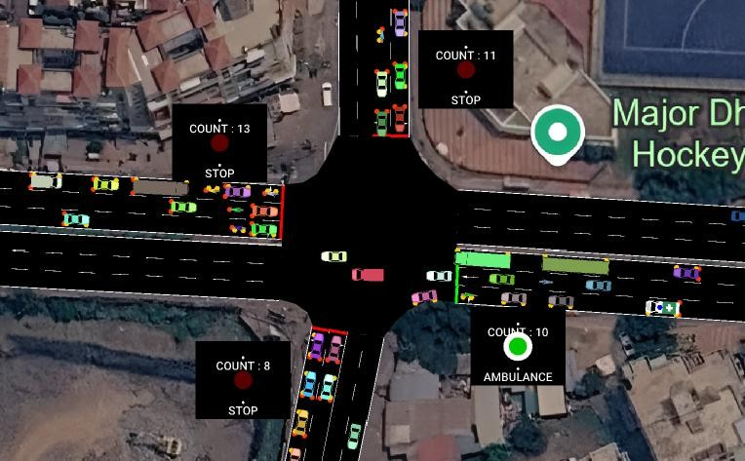

Diagram 7. E. V. Ambulance

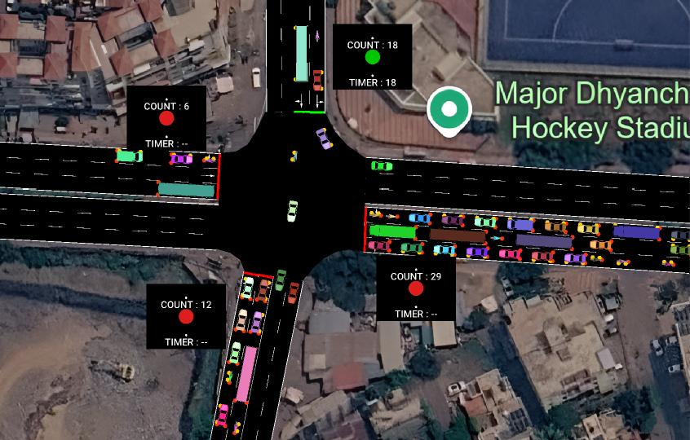
Diagram 8. Simulation with heavy congestion

Cycle time (seconds)

Diagram 9. Cycle Time Comparison — Without Logic vs With Logic
1. Cycle Time Comparison: Without Logic vs With Logic
180
165
160
140
118 118 118 118 118 118 118 118 118 118 118 118 118 118 118 118 118 118 118 118 118 118 118 118 118
120
104
100
93
96
100
84
78
84
80
76 75
70
75 76
58
58
60
60
50
56
55
50
57
55
44
40 30
20
13
0
CaseCaseCaseCaseCaseCaseCaseCaseCaseCaseCaseCaseCaseCaseCaseCaseCaseCaseCaseCaseCaseCaseCaseCaseCase
1 2 3 4 5 6 7 8 9 10 11 12 13 14 15 16 17 18 19 20 21 22 23 24 25
Case
Cycle time without logic (s) Cycle time with logic (s)

Graph 1: Cycle Time Comparison — Without Logic vs With Logic
The first graph compares the traffic signal cycle completion time without logic and with the proposed Smart Traffic Management System across 25 different cases. Without logic, the cycle time remains constant at 118 seconds for every case. However, with the proposed logic, the cycle time varies according to traffic congestion, vehicle types, and emergency vehicle conditions. The system achieves the best result in Case 15, where only one lane has vehicles, reducing the cycle time to 13 seconds. In contrast, Case 13 takes 165 seconds due to a higher E.V. count. The graph demonstrates that the proposed system reduces cycle time in most scenarios, although certain complex traffic conditions require further optimization.

OPTIMIZATION (%)
74.57
57.62
52.54
50.84
53.38
28.81
21.18
11.86
18.64
57.62
51.69
33.89
62.71
89.98
53.38
50.84
49.15
28.81
15.25
35.59
36.44
40.67
36.44
35.59

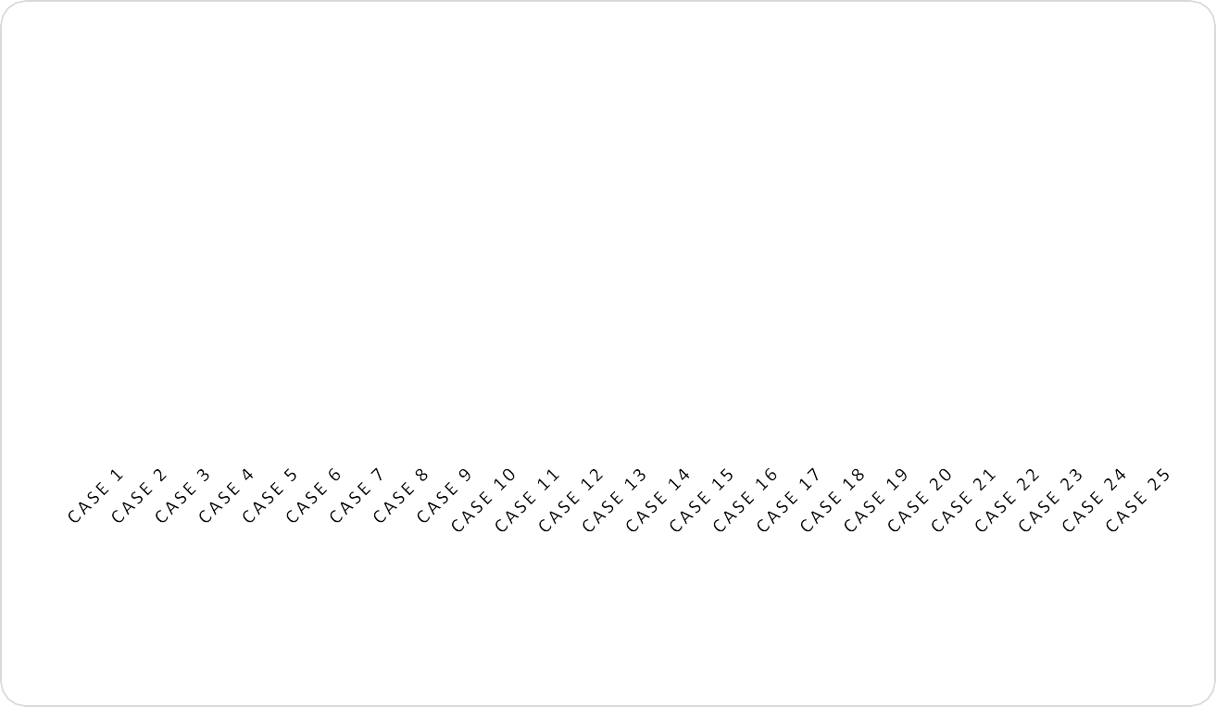
Diagram 10. Optimization Percentage by Case
2. OPTIMIZATION PERCENTAGE BY CASE
CASE
-39.83

Graph 2: Optimization Percentage by Case
The second graph represents the percentage of optimization achieved in each of the 20 cases by comparing the cycle time with and without the proposed logic. Positive values indicate a reduction in cycle time, whereas negative values indicate that the proposed system takes longer than the fixed-time system. The highest optimization is achieved in Case 15 at 89.98%, followed by Case 14 at 65.07% and Case 1 at 61.9%. However, Case 20 shows the lowest optimization at –26.98%, followed by Case 12 at –22.22%, indicating increased cycle completion times in these scenarios. Overall, the system achieves an average optimization of approximately 31.75%, demonstrating improved traffic signal efficiency in most tested conditions.

CYCLE TIME (SECONDS)
118
50
118
56
118
58
118
84
118
93
118
104
118
96
118
165
118
55
118
58
118
60
118
84
100118
118
76
118
75
118
70
118
75
118
76

Diagram 11. Emergency Vehicle Handling — Cycle Time by Scenario
3. EMERGENCY VEHICLE HANDLING: CYCLE TIME
BY SCENARIO
CASE CASE CASE CASE CASE CASE CASE CASE CASE CASE CASE CASE CASE CASE CASE CASE CASE CASE
2 3 4 6 7 8 9 13 16 17 18 19 20 21 22 23 24 25

EMERGENCY VEHICLE CASE
Cycle time without logic (s) Cycle time with logic (s)

Graph 3: Emergency Vehicle Handling — Cycle Time by Scenario
The third graph illustrates the cycle completion time for 13 scenarios involving emergency vehicle handling. The fixed-time system maintains a constant cycle time of 126 seconds, while the proposed system adjusts the timing according to different traffic and emergency vehicle conditions. In several scenarios, the proposed logic reduces the cycle time, such as Scenario 1, where it decreases to 65 seconds, and Scenario 9, where it decreases to 60 seconds. However, in Scenario 5, the cycle time increases to 132 seconds, while Scenario 13 reaches 160 seconds, indicating challenges in certain traffic conditions involving emergency vehicles. These results highlight the importance of emergency vehicle prioritization while also showing that the current logic needs further improvement to handle complex scenarios efficiently.

Back-End Representation

The back end of the system is developed using Python and the TraCI API. Python processes traffic information received from SUMO and applies rule-based logic to determine signal timings. The system analyzes vehicle count, lane density, speed, and waiting time to identify traffic demand. It also checks for ambulance presence and applies the predefined emergency-priority mechanism.Through TraCI, Python sends traffic signal control commands to SUMO, which updates the signal states and simulates vehicle movement. This process repeats continuously until the simulation ends, allowing the system's performance to be evaluated under different traffic scenarios.

Chapter 6

CONCLUSION & FUTURE SCOPES

Conclusion
The Smart Traffic Management System for Urban Congestion Control provides a simulation-based approach to improving traffic signal management. The system uses SUMO, NetEdit, Python, and the TraCI API to analyze vehicle count, lane density, speed, and waiting time to dynamically adjust traffic signal timings. It also incorporates a rule-based mechanism to prioritize ambulances under predefined conditions.The system was evaluated using 25 different traffic scenarios, including varying congestion levels, different vehicle types, and emergency vehicle situations.The observation results show that the average time decreased from 118 seconds without the decision-making logic to 70.48 seconds with the logic, achieving a reported average optimization of 40.27%. However, some scenarios showed increased time, indicating that further improvements are needed. Overall, the project demonstrates the potential of dynamic traffic signal control to reduce unnecessary waiting and improve traffic management in a simulated environment.

Future Scope

The project can be enhanced in several ways to improve its performance and practical applicability. In the future, real-time traffic data from cameras, sensors, or IoT devices could be integrated to make signal decisions based on actual road conditions. Machine learning techniques could be explored to improve traffic prediction and signal timing decisions. The system could also be extended to coordinate multiple intersections to reduce congestion across larger road networks. Additionally, the emergency vehicle prioritization mechanism can be improved to handle multiple ambulances and different emergency situations more efficiently. Further optimization of the rules for heavy vehicles, such as buses and trucks, could help address scenarios where waiting time increases. Finally, the system could be tested on more complex road networks and evaluated for potential real-world deployment.

REFERENCES / BIBLIOGRAPHY
Research Papers :
    - T. A. Mahmood and M. E. M. Ali, “Adaptive Traffic Signaling Control Using SUMO Simulator,” *International Journal of Innovative Science and Research Technology*, vol. 10, no. 1, Jan. 2025, doi: 10.5281/zenodo.14621424.

    - S. Akhter, M. N. Ahsan, S. J. S. Quaderi, M. A. A. Forhad, S. H. Sumit, and M. R. Rahman, “A SUMO Based Simulation Framework for Intelligent Traffic Management System,” Journal of Traffic and Logistics Engineering, vol. 8, no.1,pp.1–5, Jun.2020, doi: 10.18178/jtle.8.1.1-5.

    - A. Tambe and K. Uke, “AI-Powered Traffic Signal Control: A Deep Reinforcement Learning Framework for Urban Congestion Reduction,” International Journal of Environmental Sciences, vol. 11, no. 22s, pp. 4669–4676, 2025.

    - S. Das, S. Chakravarty, S. Dash, and R. Nanda, “Enhancing Traffic Monitoring Systems through Image Analysis and Rule-Based Machine Learning,” Procedia Computer Science, vol. 258, pp. 2119–2129, 2025, doi: 10.1016/j.procs.2025.04.462.

    - S. Spreeuwenberg and R. Krikke, “Development of the rule based approach to traffic management by the Dutch road authorities,” in Proc. RuleML+RR 2017, CEUR Workshop Proceedings, vol. 1875, 2017.

    - N. R. Dyavani and K. M., “Rule-based dynamic traffic management for emergency vehicle routing: A smart infrastructure approach,” International Journal of Engineering Technology Research & Management, vol. 3, no. 6, Jun. 2019.

    - A. Adnane and Y. Harkat, “Dynamic emergency vehicle prioritization in a connected urban environment: A rule-based approach,” in Emerging Cutting-Edge Applied Research and Development in Intelligent Traffic and Transportation Systems, M. Shafik, Ed. IOS Press, 2024, pp. 380–391, doi: 10.3233/ATDE241212.

    - H. Maheshwari, L. Yang, and R. W. Pazzi, “Traffic intersection simulation using turning movement count data in SUMO: A case study of Toronto intersections,” arXiv preprint arXiv:2508.10733, 2025, doi: 10.48550/arXiv.2508.10733.

    - D. Koltovska Nechoska, R. Petrevska Nechkoska, R. Duma, and M. Jovanovska Bogdanoska, “AI-based traffic control and management systems—a synthesis of Macedonian research experiences,” Transportation Research Procedia, vol. 83, pp. 513–519, 2025, doi: 10.1016/j.trpro.2025.03.020.

    - Y. H. Chow, K. J. A. Ooi, M. A. S. Bhuiyan, M. B. I. Reaz, and C. W. Yuen, “Computation and optimization of traffic network topologies using Eclipse SUMO,” Annals of Emerging Technologies in Computing, vol. 6, no. 4, pp. 31–37, Oct. 2022, doi: 10.33166/AETiC.2022.04.004.

    - [1] Indian Roads Congress, Guidelines for Capacity of Urban Roads in Plain Areas, IRC:106-1990, New Delhi, India, 1990.

DOCUMENTATION

Eclipse SUMO Documentation.
Simulation of Urban Mobility. Available at: Eclipse SUMO Official Website

Eclipse SUMO Documentation.
TraCI – Traffic Control Interface. Available at: TraCI Documentation

Eclipse SUMO Documentation.
NetEdit – Network Editor. Available at: NetEdit Documentation

Python Software Foundation.
Python Documentation. Available at: Official Python Documentation

Federal Highway Administration (FHWA).
Traffic Signal Timing Manual. Available at: FHWA Official Website

      - Project Documentation. Junction IQ - Smart Traffic Management System for Urban Congestion Control. : https://github.com/anusha130306

